Walk-in Tally Sheet
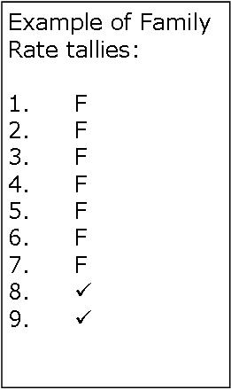Please use a check-mark for each individual ticket purchased at the $7.00 rate. Please us an “F” for each family/household ticket purchased as part of the $30 maximum rate.
1 | 46 | 91
2 | 47 | 92
3 | 48 | 93
4 | 49 | 94
5 | 50 | 95
6 | 51 | 96
7 | 52 | 97
8 | 53 | 98
9 | 54 | 99
10 | 55 | 100
11 | 56 | 101
12 | 57 | 102
13 | 58 | 103
14 | 59 | 104
15 | 60 | 105
16 | 61 | 106
17 | 62 | 107
18 | 63 | 108
19 | 64 | 109
20 | 65 | 110
21 | 66 | 111
22 | 67 | 112
23 | 68 | 113
24 | 69 | 114
25 | 70 | 115
26 | 71 | 116
27 | 72 | 117
28 | 73 | 118
29 | 74 | 119
30 | 75 | 120
31 | 76 | 121
32 | 77 | 122
33 | 78 | 123
34 | 79 | 124
35 | 80 | 125
36 | 81 | 126
37 | 82 | 127
38 | 83 | 128
39 | 84 | 129
40 | 85 | 130
41 | 86 | 131
42 | 87 | 132
43 | 88 | 133
44 | 89 | 134
45 | 90 | 135

